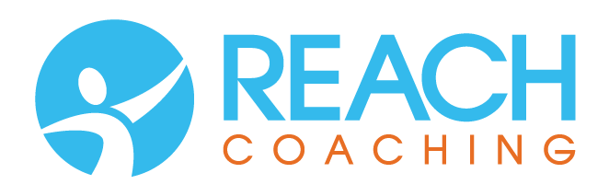

**Growth Hub**

Registration Form

Name of participant:…………………………………………………………………………………………

Address:…………………………………………………………………………………………………………..………………………………………………………………………………………………………………………..

Telephone Number:………………………………………………………………………………………….

Job/Role/Business:…………………………………………………………………...........

Position in Organisation/Business:………………………………………………………………

I confirm that:

1. I am the participant named above
2. I am registering myself for the Growth Hub Women Leaders for the full 6 month programme
3. I understand that this entitles me to attend 6 x 2 hour meetings during the duration of the programme at a total cost of £330
4. I understand that my first meeting is scheduled for October 2022 and that the subsequent 5 meetings will be confirmed at that first meeting
5. I have today agreed to pay the sum of:

☐ 1 x £330 payable at once by bank transfer OR

☐ 6 x £55 payments by monthly standing order

(Please tick as appropriate)

1. I understand that producing the results of the programme are my responsibility and that I will be supported by the Coach to do this.
2. Completion of this form constitutes my agreement to participate in and pay the full amount of the programme.

Name…………………………………………………………………………………………………………….

Signature…………………………………………… Date……………………………………………………

Please email your completed form to [info@reach-coaching.com](mailto:info@reach-coaching.com) and contact your bank to set up standing order using the details below:

Yobel Limited

Virgin Money

Account number: 29873690

Sort code:050200